Using Tangrams for Reunitizing the Whole

1) If the area of the large square ( formed by all 7 pieces) equals 1 square unit, what is the area of each piece of the tangram set?

Large triangle = _______________ Medium triangle = _______________ Small triangle = ______________

Parallelogram = _______________ Square = __________________

2) If the area of the large triangle is 1 square unit, what is the area of each of the other pieces in the set?

Large triangle = ______1________ Medium triangle = _______________ Small triangle = ______________

Parallelogram = _______________ Square = __________________

3) If the area of the square piece is 1 square unit, what is the area of each of the other pieces?

Large triangle = _______________ Medium triangle = _______________ Small triangle = ______________

Parallelogram = _______________ Square = _______1________

4) If the area of the small triangle is 1 square unit, what is the area of the other pieces?

Large triangle = _____________ Medium triangle = _______________ Small triangle = ________1____

Parallelogram = _______________ Square = __________________

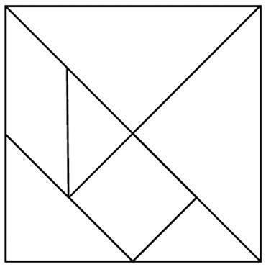

CaMSP/PRIME 2/Summer Institute/2011

