EXAMPLE 1 EXAMPLE 2

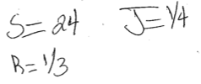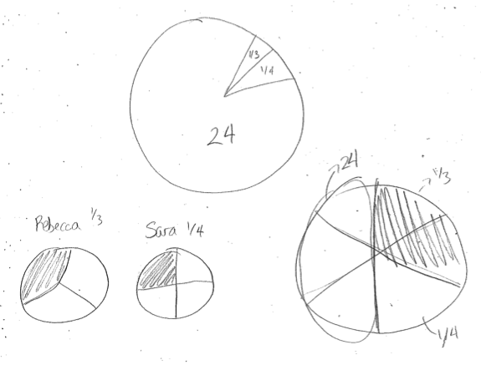

EXAMPLE 3 EXAMPLE 4

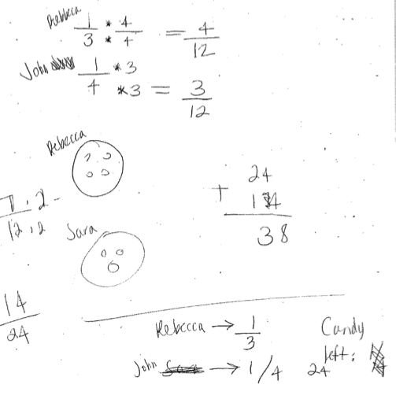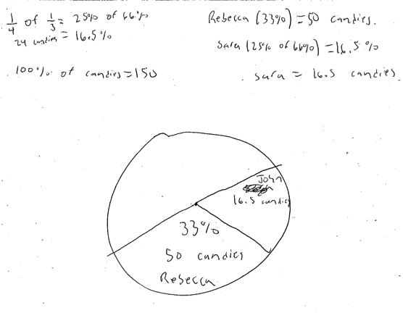

EXAMPLE 5 EXAMPLE 6

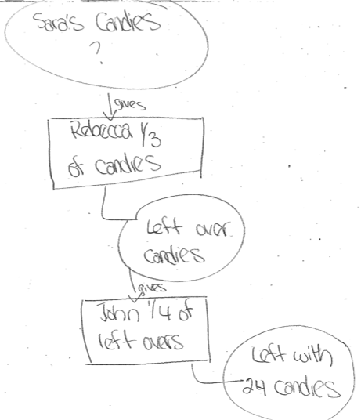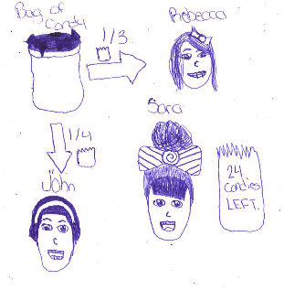

EXAMPLE 7 EXAMPLE 8

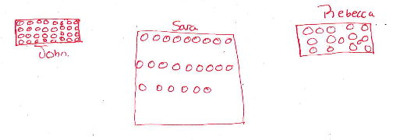 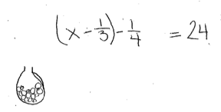

EXAMPLE 1 EXAMPLE 2 EXAMPLE 3 EXAMPLE 4



EXAMPLE 5 EXAMPLE 6 EXAMPLE 7 EXAMPLE 8

