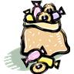
Sara’s Candy

Sara had a bag of candies. She gave ⅓ of her candies to
Rebecca. Then Sara gave ¼ of the candies she had left to
John. After giving candies to Rebecca and John, Sara had 24
candies left in her bag.

Draw a DIAGRAM that represents the important problem information.

