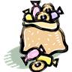
Sara’s Candy

Sara had a bag of candies. She gave ⅓ of her candies to
Rebecca. Then Sara gave ¼ of the candies she had left to
John. After giving candies to Rebecca and John, Sara had 24
candies left in her bag.
How many candies were in the bag to start?

Draw a DIAGRAM that represents the important problem information.

