AN INTRODUCTION TO MATH DIAGRAMS

Part 1

Read the math problem below and then answer the following questions.

Sara had a bag of candies. She gave  of her candies to

Rebecca. Then Sara gave  of the candies she had left to

John. After giving candies to Rebecca and John, Sara had

24 candies left in her bag.

1. Why should we really call this a problem *situation* instead of just a problem?
2. What is this problem situation about? In other words, what is the context?

Part 2

A DIAGRAM is a tool that mathematicians use to represent a problem situation so that they can better understand a math problem. Look at the DIAGRAMS below.

A. Circle the DIAGRAM that you think best represents the problem situation and helps you understand the problem**.**

EXAMPLE 1 EXAMPLE 2 EXAMPLE 3 EXAMPLE 4

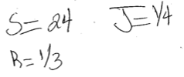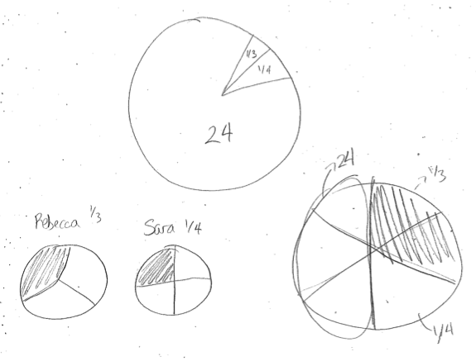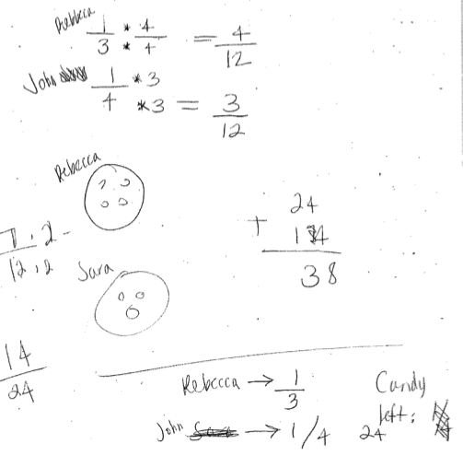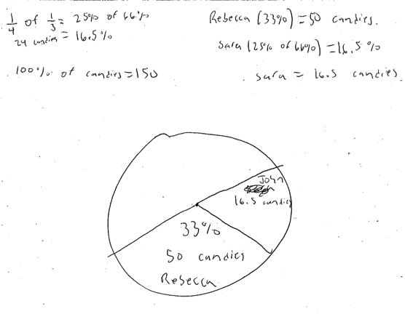

EXAMPLE 5 EXAMPLE 6 EXAMPLE 7 EXAMPLE 8

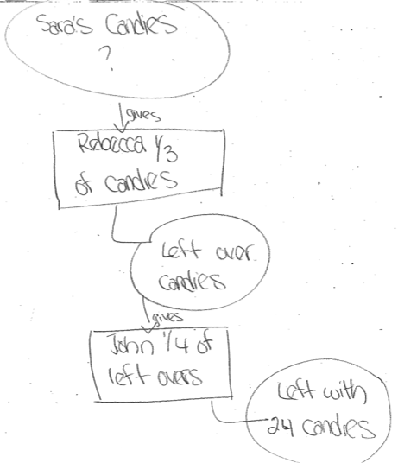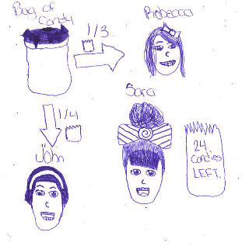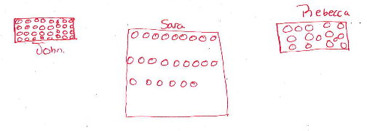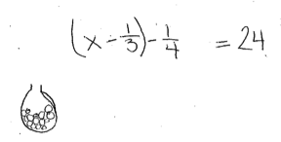

B. Give up to 5 reasons why you think the diagram you circled helps you understand the problem situation.

Reason #1:

Reason #2:

Reason #3:

Reason #4:

Reason #5:

C. Look at the DIAGRAMs again. Identify the diagram you think is **least** helpful for understanding the problem. Then complete the following:

DIAGRAM # does NOT help me understand the problem because

Part 3

A really good DIAGRAM will help you to “see” a way to solve the problem. Suppose the question for the problem above was “HOW MANY CANDIES WERE IN SARA’S BAG TO START?”.

A. Which DIAGRAM helps you “see” a solution strategy? DIAGRAM # .

B. Show or explain that solution strategy.